**Assignment Advance Programming Lab 4**

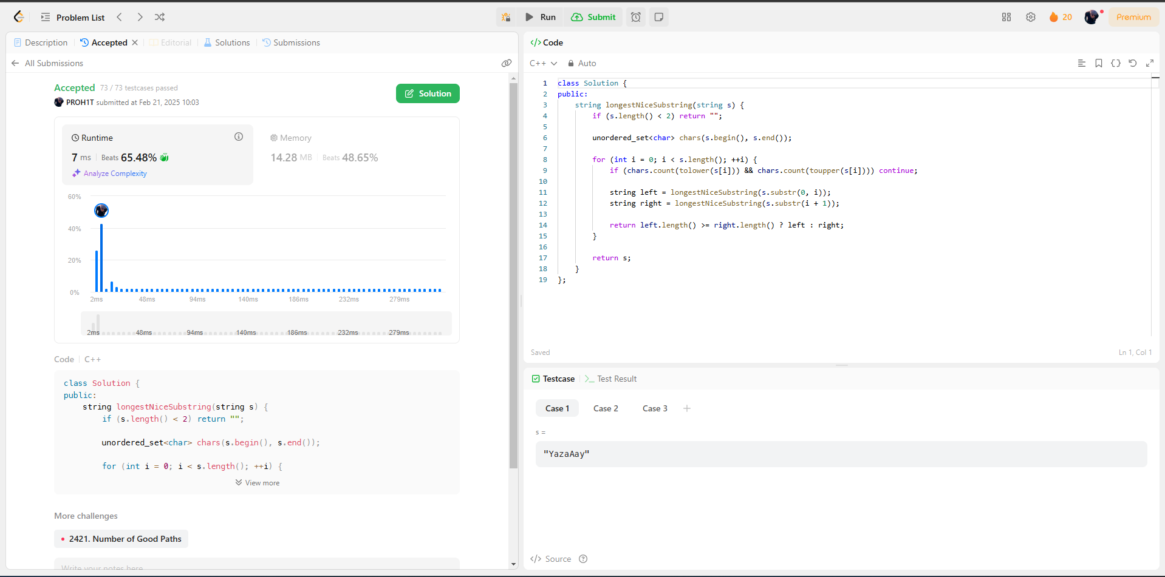[**1763. Longest Nice Substring**](https://leetcode.com/problems/longest-nice-substring/)

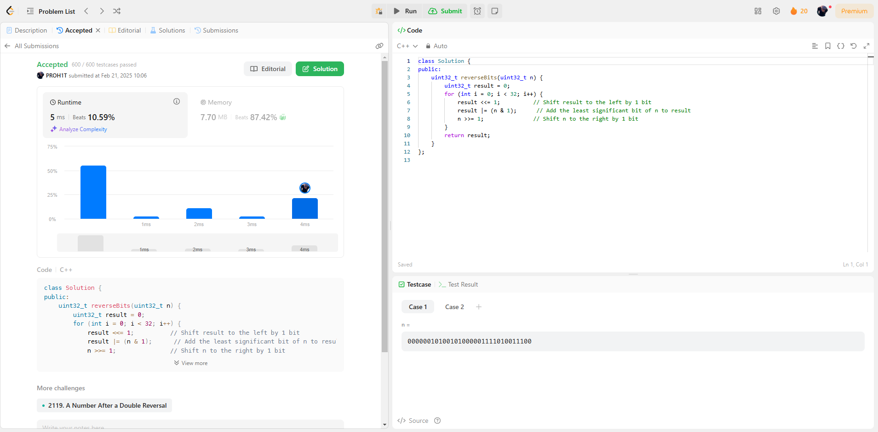[**190. Reverse Bits**](https://leetcode.com/problems/reverse-bits/)

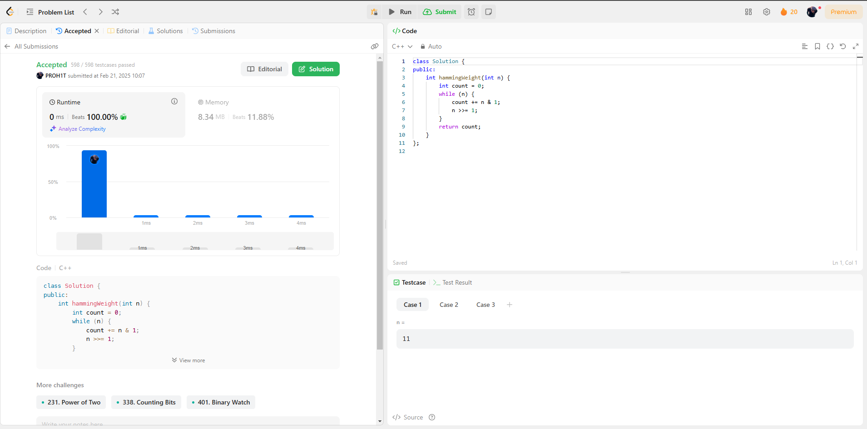[**191. Number of 1 Bits**](https://leetcode.com/problems/number-of-1-bits/)

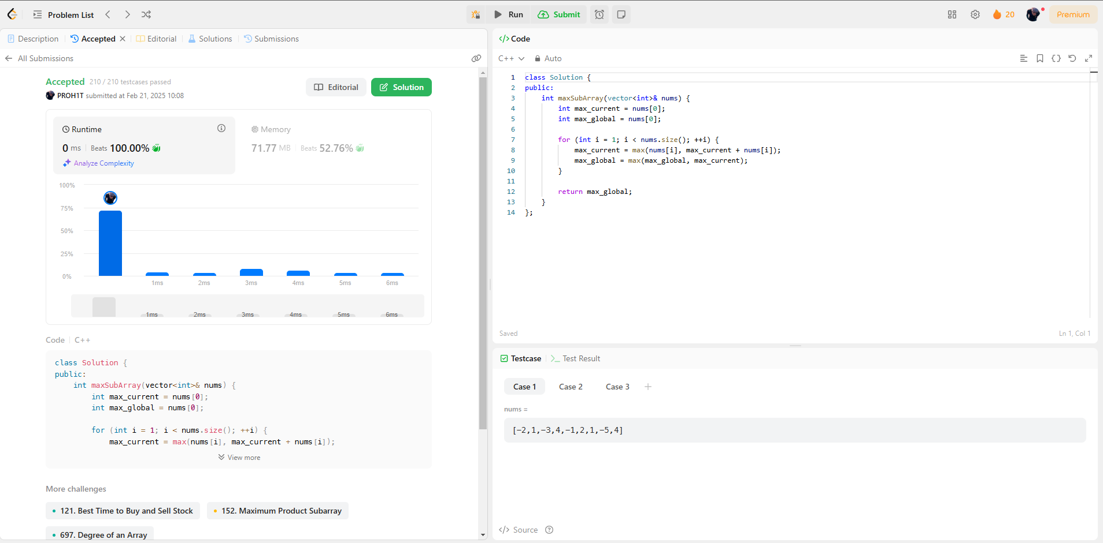[**53. Maximum Subarray**](https://leetcode.com/problems/maximum-subarray/)

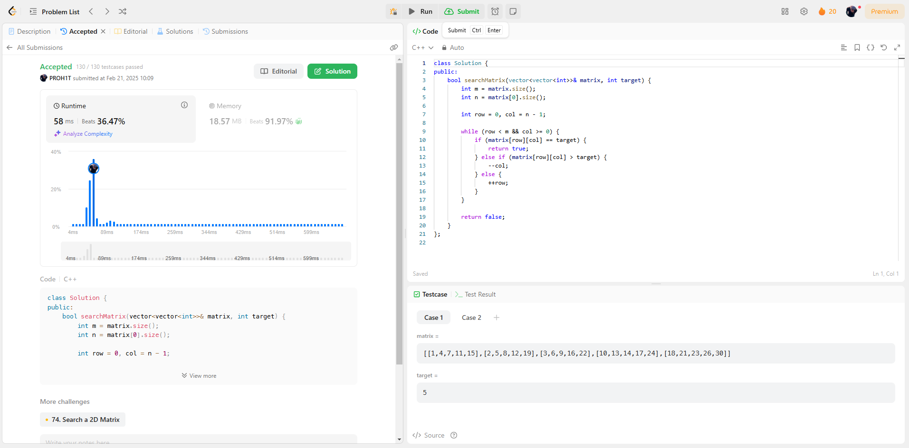[**240. Search a 2D Matrix II**](https://leetcode.com/problems/search-a-2d-matrix-ii/)

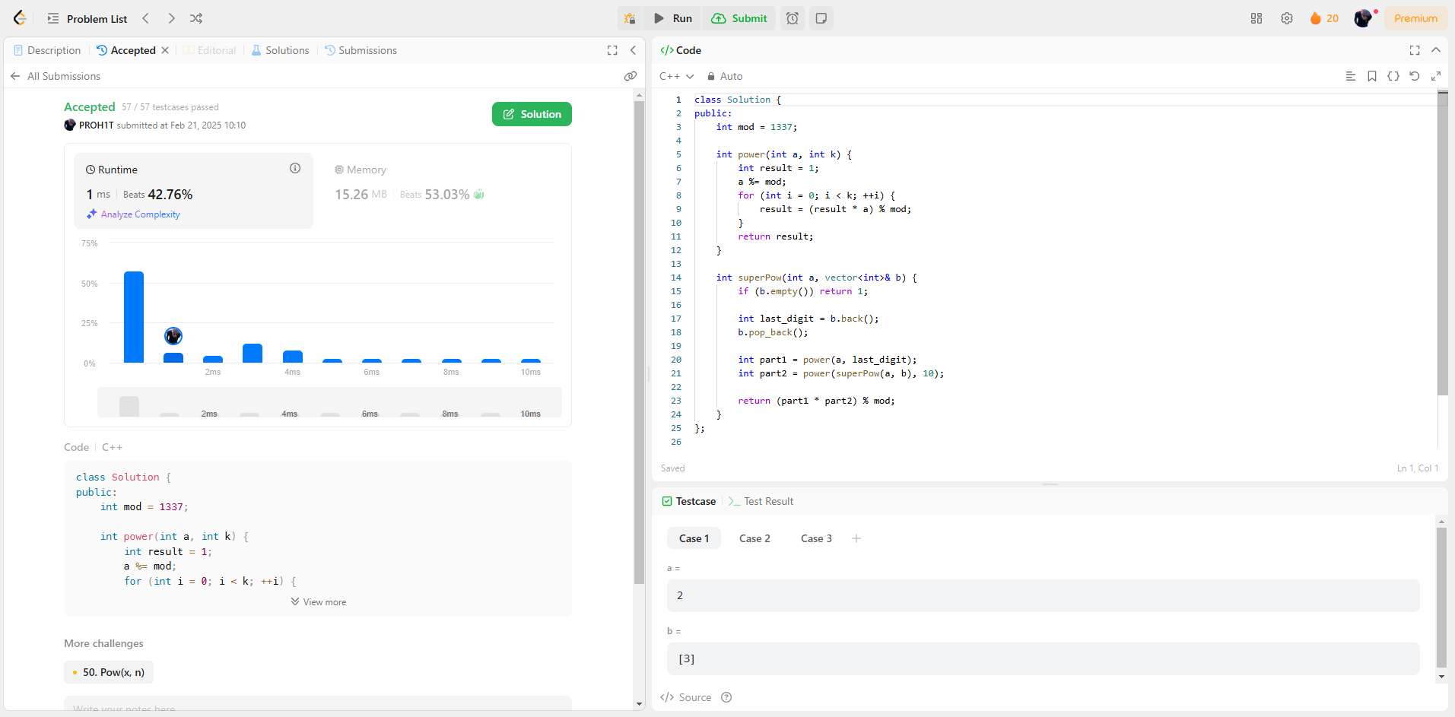[**372. Super Pow**](https://leetcode.com/problems/super-pow/)